Stage 3 – Somebody hadda do it. I am the chosen one.
COURSE DESIGNER: Ike Starnes
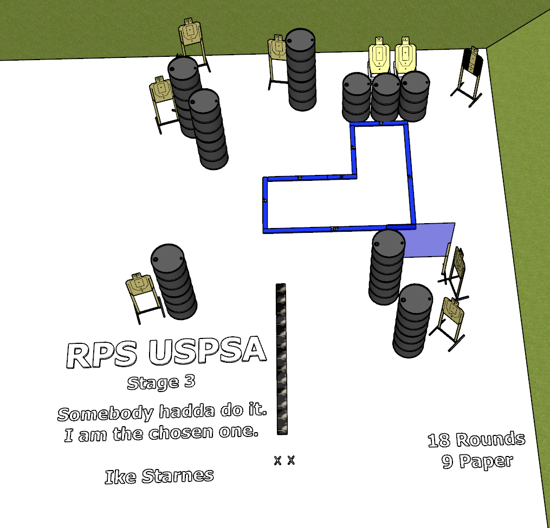

Written Stage Briefing:
Stage 3 – Somebody hadda do it. I am the chosen one. - is an 20 round, 100 point, Comstock course. There are 10 cardboard targets. The best 2 hits per cardboard target will be scored.
Start position is both feet on the Shooting Sports Innovations Xs.
Handgun loaded and holstered, wrists below belt.
PCC loaded, stock on belt.

Setup Notes:
2 Single Wall Stands
1 Half Wall
8 Target stands / 16 target sticks
2 45 degree target stands / 4 short sticks
16+ barrels


